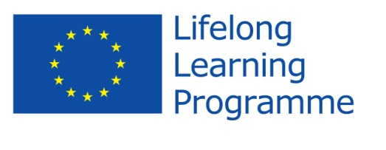

EVALUATION OF THE FIRST YEAR OF THE PROJECT: “EU TEENS IN SEARCH OF NEW ROLE MODELS“:
LOCAL JUNIOR CAFFE
PARTNER: Secondary school Bedekovčina
DATE: 14th June 2013
NUMBER OF PARTICIPANTS: 5 teachers and 10 students
CONCLUSIONS:
STRENGTHS:  - during the activities and spending time with students from other countries, both teachers and students had the opportunity to practice and improve their English language skills  - we got to know other people's culture and lifestyles  - we exchanged ideas about role models and the criteria by which they were chosen with our peers from other countries  - both teachers and students got to know each other better during socializing on project meetings and activities | WEAKNESSES:  - it is quite difficult to coordinate the dates of meetings due to work in different shifts  - most of the students who are members of the project team do not have appropriate IT skills, in effect, the largest part of the work (on computers – creating presentations, posters) is a work of individuals  - students who have taken part in the travelling do not attend meetings regularly (after the travelling)  - a certain number of students from other partner-states do not have a good command of the English language and because of that it has been difficult to communicate with them
OPPORTUNITIES:  -making new friends  -getting to know new states  - spotting the differences and similarities in lifestyles of people from other partner –states  - doing something completely new in a completely new environment  - perceiving the new criteria for choosing positive role models or identifying undesirable personal traits  -acquiring new experiences from socialising with people from a different social environment, culture and lifestyle | THREATS:  - In some countries, it was very difficult to communicate with host students (in Turkey  - Students communicated via Google Translate

Bedekovčina, 15th June 2013 Coordinator: Daniela Usmiani

