EU Teens In Search of New Role Models
Hrvatski mladi u potrazi za novim uzorima
2012. – 2014.
KNJIŽICA ESEJA UČENIKA SŠ BEDEKOVČINA
This project has been funded with support from the European Commission. This communication reflects the views of the author only, and the Commission cannot be held responsible for any use which may be made of the information contained therein.
Multilaterarni Comenius projekt između 8 zemalja, pod pokroviteljstvom Agencije za mobilnost,u potpunosti financiran od strane EU.
Kada sam dobio zadatak opisati osobu kojoj se divim i koju držim svojim uzorom, nisam se premišljao i odmah sam znao o kome ću pisati - o svome ocu. Inženjer građevine, ustrajan i pametan, plemenit i duhovit, pun ljubavi kad se radi o obitelji, a s druge strane hladne glave kada je o poslu riječ, ali prije svega toga, moj je otac.
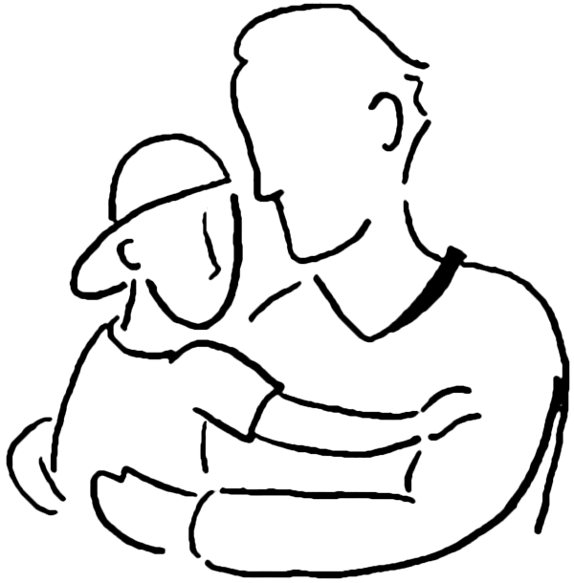
Moj se otac svojim poslom bavi cijeli svoj radni vijek i iskusio je i dobro i loše u svim segmentima građevine. U svojim pričama o djetinjstvu, odrastanju i samom školovanju kako bi dospio do onoga čemu je težio, uvijek govori s posebnim žarom u očima i laganom sjetom za prošlošću. Priče kada je kao dječak od samo pet godina vadio sa svojim ocem kamenje, kada je bosonog pješačio četiri sata do škole, kada je, došavši u Zagreb na fakultet, bio primoran raditi kako bi mogao platiti školovanje, paralelno radeći u tvornici i vraćajući se svake večeri u hladnu sobicu podno Britanskog trga i lijegajući prazna želuca svakih večeri u smrznuti krevet, izazivaju u meni divljenje i osjećaj zahvalnosti. Često se pitam što je to što ga je tjeralo naprijed, zašto se nije vratio kući gdje bi mu bilo lakše… Mislim da je to bilo ono kada kažu da netko želi više od života, kada želi dati sve od sebe i iskoristiti sve što ima kako bi mogao onima koje voli pružiti ono što on nije imao već stekao vlastitom mukom. To je što mi moj otac uvijek govori i nastoji da shvatim što znači steći nešto vlastitim rukama i radom. Ponosan sam što imam takvoga oca, ponekad se zamislim kada po pričama zaključim koliko ga ljudi cijene i poštuju jer usprkos svakojakim situacijama, ostao je dostojan svoga imena i časti, usprkos mnogim razočarenjima nije tražio osvetu i glumio pravednika, nego je uvijek i u svemu, zadržao hladnu glavu. I tu lekciju pokušavam naučiti!
Zato je on moj uzor, njegov duh koji je uvijek pun vedrine, novih ideja, on nikada ne posustaje čak i kad je najgore, on je uvijek pozitivnog mišljenja, on je još puno toga ali riječima teško mogu opisati svoju beskonačnu ljubav i zahvalnost i nadu da ću jednoga dana biti slika i prilika svoga oca.
When I got the assignment to describe a person I admire, I immediately knew who I would write about – my father – a civil construction engineer, persistent, intelligent, noble, funny and loving when it comes to his family and, on the other hand, keeps a cool head when it comes to business. But, above all, he is my father.
My father has been into this job all his working lifetime and has experienced the good and the bad aspects of civil engineering. When he talks about his childhood, growing up, education and making his dreams come true, he always has a special spark in his eyes and melancholy in his voice.
The stories of him, a five-year-old boy, quarrying stone with his father, walking four hours to school barefoot, working his way through college in a factory and coming back to his cold, shabby room on Britanski trg and going to cold bed without dinner fill me with awe and gratefulness.
I often wonder what kept him going on, why he didn't return home where things would be easier for him…
I think it was the case of wanting more from one's life, od doing one's best and using one's resources to give their loved ones the things they didn't have, but had to earn them in the hard way.
This is what my father always tells me and tries to make me understand what it means to create something with your own hands and hard work. I am proud of having such a father. I sometimes become thoughtful when I conclude from people's stories how much they appreciate and respect him because, despite all kinds of situations, he remained worthy of his name and honour, despite many disappointments he didn't ask for revenge and pretend to be righteous, he kept a cool head in every situation. And this is the lesson I have to learn!
This is why he is my role model, his spirit is always full of cheerfulness and ideas, he never gives up even in difficult moments, he always thinks positively, he is much more but words cannot describe my endless love, gratefulness and hope that someday I will be like my father.

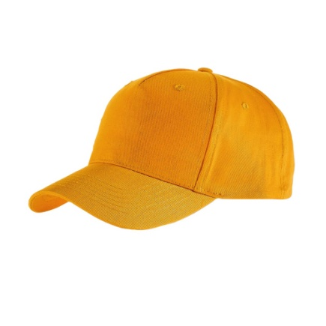
Uzorom se danas nazivaju mnogi ljudi, mogu reći da čak i postoje vrste uzora. Kada bismo morali odabrati svojeg uzora, bi li to bio netko tko je već u našem životu ili neko tko je samo djelić našeg života, a zapravo nikad nije ni bio u njemu. Moj uzor, možda ga ne bih tako nazvao, ali osoba kojoj se ja divim jest Marshall Bruce Mathers 3 svima poznatiji kao Eminem. Zašto baš on? Pa on je pravi primjer ljudskog uspjeha. Od padova, razočaranja, gubitka supruge, kćeri, novca, oca uspio je izvući i napraviti ono najbolje. Pretpostavljam da mu je životni moto "Uzmi što ti život pruža i napravi najbolje od toga". Možda je i zbog toga moj uzor, ja nikad ne bih imao toliko snage i volje kao što je to on imao.
Bijelac i reper, same te dvije riječi već vas tjeraju na smijeh. Svima je poznato da su danas najpoznatiji reperi upravo crnci. No Eminem je preokrenuo svijet i pokazao svima nama da se ljudsko društvo NE dijeli na bijelce, crnce, visoke, niske, žute, bolesne, već da smo svi isti. Isto tako ne smijem zaboraviti napomenuti njegovu snagu i želju za uspjehom. Budimo iskreni, ako vam živo opali tri puta šamarčinu, hoćete li uistinu izađi pred njega i pokupiti i četvrtu ili ćete se povući? On je izašao po tu "četvrtu šamarčinu" i umjesto šamarčine osvojio je publiku, svijet.
Dokazao je ne samo meni već svima nama da bez padova i muke nema uspjeha. Koliko god nama bilo teško, život je jedan i nikad nesmijemo izgubiti borbu za onim što volimo ili onim što jesmo

Today, we can say that a lot of people are role models, but there are also different types of role models. If we were to choose our role model, would it be someone who is in our life or someone who makes just a small fraction of it and has never been there either?
My role model, actually, not a real role model, but the person I admire is Marshall Bruce Mathers III, known as Eminem. Why he? Well, he is an example of a true success. He made he best of his falls, disappointments, losing his wife, daughter, money and father. I assume his motto is ''take what life gives you and make best of it''. Maybe this is why he is my role model. I think I wouldn't have had so much strength and will like he did. He is white and he is a rapper – these two facts must make you laugh. Everybody knows that today's most famous rappers are African-American. However, Eminem turned the world upside down and showed to all of us that you cannot divide people into black, white, tall, sort, yellow or sick, but that we are all the same. I also mustn't forget to point out his strength and wish to success. Let's be honest, if life knocked you down three times, would you get up the fourth time or would you just stay lying on the floor? He got up the fourth time and instead of being knocked down, he won his audience and the world.
He proved, not just to me, but to all of us, that there is no success without hard work. No matter how difficult life can sometimes be, we have only one and we cannot afford losing the fight for what we like or are.

Svatko se od nas barem jednom upitao kakav je to život slavnih osoba. Je li taj život stvaran, takav kakvog nam nameću mediji ili je to sve samo laž? Mnogi su postali slavni samim time što su se rodili u slavnoj obitelji, a mnogi su sami, svojom upornošću i željom stekli slavu i poštovanje. Jedan od takvih koje cijenim i poštujem jest Lionel Messi.
Lionel Messi je argentinski nogometaš koji je karijeru nastavio u španjolskom klubu Barcelona. Danas se Messi smatra najboljim nogometašem svoje generacije, a njegov put do titule najboljeg je bio sve samo ne lagan. Još je kao dijete gajio veliku ljubav prema nogometu. U 11. godini dijagnosticiran mu je manjak hormona rasta. Njegovi roditelji mu nisu mogli priuštiti liječenje, stoga je sva borba za napretkom ostala na njemu i njegovom trudu što nije promaklo vodećim ljudima nogometnog kluba Barcelone koji su mu ponudili financiranje liječenja uz uvjet da se preseli u Barcelonu i nastavi igrati za njih. Messi je zauzvrat ostao vjeran Barceloni, nije mijenjao klub, postao najboljim nogometašem današnjice čime se ujedno i odužio klubu za sve učinjeno za njega.
Ono što izuzetno cijenim kod Messija jest upornost, požrtvovnost i odanost. Pokazao je cijelom svijetu da je uz veliku volju i trud sve moguće. Pokazao je da se trud i upornost stvarno isplate, u što ljudi često posumnjaju ukoliko ne postignu cilj iz prvog pokušaja.

Everyone has at least once asked themselves what life of famous people is like. Is this life real, is it the way it is portrayed by the media, or is it just a big lie? A lot of people became famous just by being born into a famous family, others gained fame and respect by working hard to fulfil their dreams. One of these people I admire and appreciate is Lionel Messi.
Lionel Messi is an Argentinian football player who continued his career in FC Barcelona. Today, Messi is thought to be the best football player of his generation and his path to the title of the best way anything but easy. As a child he was keen on football. At the age of 11 he was diagnosed with growth hormone deficiency. His parents couldn't afford the treatment so he had to fight for success on his own. This didn't go unnoticed by lead people of FC Barcelona who offered him to finance his treatment on condition that he move to Barcelona and continue playing for them.
In turn, Messi remained faithful to Barcelona, he didn't change his club, he became the best contemporary football player, and thus repaid everything his club had done for him.
What I value about Messi is his persistence, commitment and loyalty. He showed to the whole world that, with great effort and will power anything is possible. He showed that effort and persistence are really worthwhile and this is something people start questioning when they don't succeed in something the first time they try it.

Meni je uzor moj otac zato što je, po mom mišljenju, jako uspješan u svome poslu, a po zanimanju je podopodlagač. Također bi mogao biti uzor i drugima jer se brine o svojoj djeci i zna nam se prilagoditi.
Najviše mi se kod njega sviđa što će mi pomoći oko neke najveće gluposti za koju bi rekao da on nema vremena, ali on, ako ima puno problema oko posla i ostalog, jednostavno zaboravi na sve brige i probleme i razgovara i druži se sa mnom, kao s najboljim prijateljem. Naravno, sviđa mi se to što je i s ostalim mojim prijateljima u razgovoru kao i mi. Također, kada je i sa svojim društvom, zna se prilagoditi svakoj osobi što je za mene jako dobra osobina. Kada sam morao odlučiti koju ću školu pohađati, odabrao sam smjer građevinski tehničar kako bih išao njegovim stopama jer me to jako interesira i želio bih jednog dana biti isti kao on.
Kada je on dobre volje i kada je sretan i bez briga, tada se i ja jako sretno osjećam pored njega. Mogu dodati i primjer od ovog ljeta kada smo bili na moru, pitao je moje sestre i mene da se idemo voziti gliserom na tubi ili na skijama. Ja sam, naravno, rekao da jer sam vidio da mu je dosadno i da se želi zabavljati. Na žalost, sestrama se nije dalo, ali svejedno smo išli on i ja i sami smo se ludo zabavljali.

My role model is my father whom I consider to be successful at his job – he is a floor fitter. In addition, he could be a role model to other people because he takes care of his children and is able to adapt to them.
What I like about him best is his readiness to help me even about silly thing. Although he is a busy man, he puts his worries aside and spends time with me like my best friend. I also like when he talks to my other friends. When he is with his friends, he can also adapt to various kinds of people, which I think is a great character trait. When I had to decide which school to enrol at, I chose the one for civil construction technician because I wanted to follow his footsteps and this is the profession I am really interested in. I would like to be like my father someday.
When he is in a good mood, happy and worriless, I feel endlessly happy next to him. For example, last year we were at the seaside and he asked me and my sisters to take a ride on a tube speedboat or go water-skiing. Of course I immediately said 'yes' because I saw he was bored and wanted to have fun. Unfortunately, my sisters declined, but we went anyway and had the time of our lives!

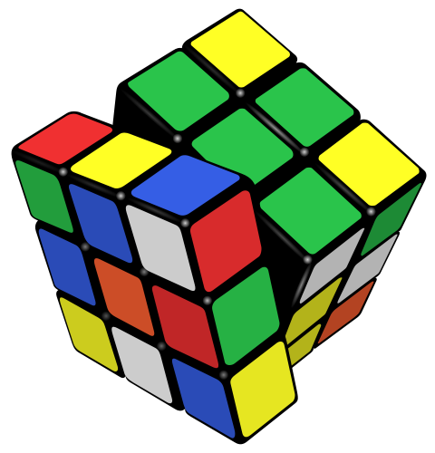
Govoreći o uzorima, prvo na koga pomislim je moj djed. Moj djed Stjepan vrlo je posebna osoba, a kako živimo u istoj kući, poznajem ga od rođenja i s njim provodim puno vremena. On je u mladosti radio kao dizajner cipela, a kasnije je pokrenuo vlastiti obrt za postavljanje parketa. On je zaslužio da bude moj uzor jer je vrlo uporna osoba, a sve što zamisli ostvari.
Moj djed je vrlo pametan, radišan i ništa ne prepušta slučajnosti. Volim njegove priče o djetinjstvu i prošlosti jer je njegova obitelj bila vrlo siromašna, ali on s ponosom govori o svemu što je proživio i ništa ne bi mijenjao. Moj djed djeluje čvrsto, međutim on je vrlo osjećajan, ali to rijetko pokazuje. Njemu je obitelj na prvom mjestu i često nas sve okuplja zajedno. Također, moj djed jako puno radi. Ima 64 godine, a radi kao da ima 25. On je pun pozitivne energije i želje za aktivnostima. Stalno unaprijed planira. Divim se njegovoj upornosti. On nikad ne odustaje od nečeg što želi. Vrlo je optimistična osoba i s osmjehom gleda na život i ljude. Sviđa mi se posao koji moj djed obavlja, ali ne radi se toliko o poslu nego njegovoj želji da napravi bilo što. Prije nekoliko mjeseci moj je djed naučio koristiti internet te je naručio rezervne dijelove za traktor i preuredio ga. To je samo jedan primjer kako se on ne boji izazova.
Često mi govore da sam naslijedio osobine djeda, ali on je za mene još uvijek jedinstven i ugledam se u njega. Divim se njegovoj upornosti, hrabrosti i velikom srcu.

Speaking of role models, the first person that comes to my mind is my grandfather. My grandfather Stjepan is a very special person, and, since we live in the same house, I have known him my whole life and spend a lot of time with him. As a young man, he was a shoe designer, and later he set up his own business in fitting wooden floors. He deserved to be my role model because he is a very persistent person and makes his dreams come true.
My grandfather is very smart, hard-working and leaves nothing to coincidence. I like his stories about his childhood and past because his family as very poor, but he is proud of life and wouldn't change a bit.
My grandfather comes across as a tough man, however, he is really sensitive, but rarely shows it. His family is always first and he often brings us together. Also, my grandfather works really hard, he is 64 and works like he is 25. He is full of positive energy and always willing to do something. He always make sup new plans. I admire his persistence. He never backs down from something he wants. He is an optimistic person who always looks on the bright side of life. I like my grandfather's job, but it is not actually the job itself - it’s about his willingness to accomplish anything. A couple of months ago, my grandfather learned how to use the Internet, he ordered spare parts for his tractor and restored it. This is just one of many examples showing he is not afraid of new challenges. I am often told to have inherited my grandfather's traits, but he is still unique to me and I look up to him. I admire his persistence, courage and big heart.

Moj uzor je Mirko Filipović,u svijetu poznatiji kao Cro Cop. Mirko Filipović je hrvatski boksač, K-1 borac, kickboksač, borac mješovitih borilačkih vještina te jedan od najuspješnijih sportaša Hrvatske. Iako je već blizu 40-e godine života, Mirko Filipović još i danas pokazuje svoju upornost, fizičku spremnost te izdržljivost u svojim borbama s puno mlađim i talentiranijim borcima. Iako u posljednje vrijeme nije nanizao mnogo pobjeda, u mlađim danima Mirko je bio izuzetno dobar te osvajao mnoge naslove i pobjeđivao na mnogim turnirima sa jakom konkurencijom. Za Mirka sam čuo na televiziji i nažalost nisam ga još imao prilike upoznati.
Mirko se sportom počeo baviti od „malih nogu“ te je svojom upornošću postao svjetski poznata i cijenjena osoba. Mirko ne samo da je dobar sportaš, nego je i zagovaratelj zdravog načina života, bez droge i alkohola, trenira osam sati dnevno, putuje po cijelom svijetu, a uz to živi kvalitetan obiteljski život sa ženom i dvoje djece. Smatram da bi Mirko zbog toga trebao biti uzor mnogim ljudima, a naročito mlađim uzrastima te im pokazati da se ni iz čega može postići „nešto“, baš kao što je to i on učinio. Izgubio je mnogo borbi, ali nakon toga trudio se i trenirao još više te se hrabro vraćao u ring.
Unatoč sportu kojim se bavi, Mirko je vrlo smirena osoba,uvijek raspoložena za razgovor i šalu kao što je i pokazao na različitim intervjuima. Mirka sam odabrao kao uzora zbog njegove životne priče koja nam iznosi pouku da se upornošću i radom može postići vlastiti cilj ma koji god on bio.
My role model is Mirko Filipović, known in the world as Cro Cop. Mirko Filipović is a Croatian boxer, K-1 fighter, martial arts fighter and one of the most successful athletes in Croatia. Although he is almost 40, he is still showing his persistence, physical strength and endurance in fighting much younger and talented fighters. Although he hasn't won many fights, back in the early days, Mirko was extraordinarily good and won numerous titles in difficult competitions. I heard about Mirko on television but, unfortunately, still haven't got the chance to meet him in person.
Mirko has been into this sport since he was a child, and his persistence made him a world-wide famous and appreciated person.
Not only is he an excellent athlete, bt he is also a promoter of healthy life without alcohol or drugs, he trains eight hours a day, travels around the world and has a quality family life with his wife and two children. I think Mirko should be a role model to many people, especially young people, and show them that you can create something from nothing, just like he did. He has lost many fights, but after that he tried harder and trained harder and always came back in the ring. Despite his sport, Mirko is a very calm person and always ready to make a conversation or a joke, which he showed in a couple of interviews. I chose Mirko to be my role model because of his life story that shows us that you can accomplish your goal with persistence and hard work.

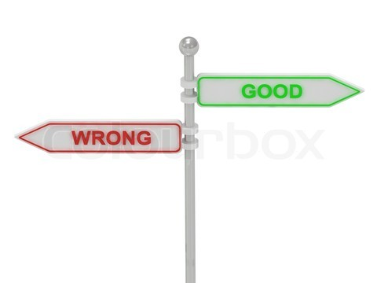
Moj uzor je netko tko me pazio i čuvao odmalena i tko je znatno utjecao na moj odgoj i život. Tata je moj uzor! Posjeduje mnogo dobrih vrlina i postupaka kojim se divim i želio bi biti poput njega. On se brine za mene i moju braću, voli nas, puno radi i odriče se mnogih stvari samo zbog nas te nas je podučio ustrajnosti, suživotu, poštovanju, odgovornosti te mnogo više.
U suživotu s mojim ocem saznao sam da je on otac koji brine o drugim ljudima te o meni i braći da imamo svijetlu budućnost. Uvijek je smiren i strpljiv sa mnom te jako drži do toga da i ja sam u budućnosti postanem uzor. U obitelji smo mi, djeca, oni o kojima brine najviše i uvijek će izdvojiti vremena da popriča s nama i da nam pomogne ili dade neki savjet. Na primjer, kad sam u osnovnoj školi dobio svoju prvu jedinicu, tata je porazgovarao sa mnom i rekao je da je pametnije da učim jer će mi to donijeti bolji i lakše stečen posao i, također, više ću zarađivati i moći ću pomoći obitelji. Na svojem primjeru mi je pokazao da on sam nije pratio nastavu i da je trebao mnogo više marljivo raditi da bi postigao što ima danas. Nije da mi samo daje dobre savjete već mi i pomaže oko škole ako nešto ne razumijem te da trebam imati poštovanja prema drugim ljudima te nas podučava moralu i njegovom najvažnijom vrijednosti koja je „dobro“. Njemu je imati moral (dobar osjećaj za dobro) jako bitno jer ne da će nas to učiniti boljom osobom, već će nam pomoći postići što želimo u životu.

My role model is a person who looked after me when I was little and who significantly influenced my education and life. My father is my role model!
He has many virtues and good actions I admire and I wold like to be like him. He takes care of me and my brothers, he loves us, works hard and makes sacrifice to teach us how to be persistent, tolerant, polite, responsible, etc. Living with my father made me realise he a person who takes care of people, me and my brothers so that we have a better future. He is always calm and patient, and eager to see that I have become someone else’s role model. He takes a lot of care about his children, and always finds time to talk with us, help us or gives some advice. For example, when I got my first ‘F’, he talked to me and said it was smarter to learn because that would give me a better job and I would be able to make more money and help my family. He told me he hadn’t paid attention in classes so he had to work harder to get what he has now. Not only does he give me advice, but he also helps me with school if I don’t understand something and says that I should respect other people. He also teaches us to differ right from wrong and how to value the ‘right’. It is very important to him to have a sense of moral because this makes us better people and it will help us to succeed in life.

Svatko u životu ima barem jednu osobu kojoj se divi i koju cijeni. Meni je moj uzor moja majka Jasna, koja iako radi vrlo težak posao, ispunjava svaki dan braći i meni veseljem i toplinom. Kažu da je rad s ljudima jako težak posao, no moja majka i nakon posla ima snage i volje uživati u našim zajedničkim trenucima. Kažu da je najteži posao biti majka,slažem se!
Gledajući je kako svaki dan odlazi na posao, ponekad i zažalim što ima takav posao. Ipak je teško biti medicinska sestra, mnogo ljudi koji bespomoćno leže u krevetu, i kad ih sagledam, zahvalim se Bogu što imam takvu divnu osobu ispunjenu vedrinom koja mi uveseljava život. O njoj mogu reći samo riječi hvale: to je jedina osoba kojoj vjerujem, koja mi daje snagu da ustanem ujutro, koja me vodi na pravi put, kojoj u potpunosti vjerujem. Ona me devet mjeseci nosila u utrobi, a nakon tih mjeseci donijela na svijet, pružila mi lijepo djetinjstvo, pomogla mi u učenju, bila uz mene u dobrim i lošim danima. Ona je ta koja me naučila cijeniti druge osobe i učinila me takvom osobom kakva sam sad. Njoj dugujem sve, baš kao i moja braća. Vrlo je mirna osoba, no ja sam malo temperamentan i zna doći do konflikta. Ali poslije se pokajem i ispričam jer znam da nakon napornog dana najmanje što joj treba jest svađa između nas dvoje.
Bez moje majke Jasne život bi mi bio nezamisliv. Osoba kao moja majka može se samo poželjeti. Uvijek je tu uz mene, bodri me, pomaže mi u životu, usmjerava me na pravi put. Zbog takve majke vrijedi se svaki dan zahvaliti Bogu. Zbog toga sam sretan što je braća i ja imamo uz sebe.
Everyone has at least one person they admire and appreciate. My role model is my mother Jasna, who does a very difficult job, and brings joy and warmth to me and my brothers. People say that working with people is very difficult, but my mother manages to find strength and will to enjoy our moments together. It is said that being a mother is the most difficult job in the world. I agree! When I look at her going to work every day I feel sorry she has a job like this. It is difficult to be a nurse – there are a lot of people who helplessly lie in their beds, and when I think about them, I am grateful to have such a wonderful, cheerful person that makes my life happy. I can only say words of praise about her: she is the only person I trust, who gives me the strength to get up in the morning and who shows me the right way. She brought me to this world, gave me a wonderful childhood, helped me with homework, and led me through my good and bad days. She taught me to respect other people and made me the person I am today. My brothers and I owe her everything. She is a very calm person, but I sometimes have a bad temper so we have a quarrel from time to time. But later I feel and say sorry because I know that, after a hard day at work, the least she needs is a fight between us. I can’t imagine my life without my mother Jasna. You can only wish for a person like my mother. She is always there for me, encourages me, helps me and leads me the right way. One should thank God every day to have a mother like mine. We are happy to have her with us.

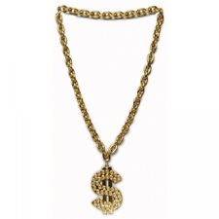
Moj uzor je Curtis Jackson, slavni reper poznat pod imenom 50 Cent. Prvi put sam došao u doticaj s njim kada sam na MTV-u gledao njegov video-spot pjesme zvane „In da club“. Odlučio sam malo više otkriti o životu slavnog repera i saznao da može biti uzor meni i drugima jer je imao teško djetinjstvo.
Kod 50 Centa mi se najviše sviđa način na koji repa. Jako je važno znati „repati“ jer to ovisi o karijeri i slavi. Kada je bio mali, uz dilanje droge prodavao je i svoje pjesme. Živio je s djedom i bakom jer su mu roditelji umrli. Nakon što se ostavio dilanja droge zbog potrage za reperskom karijerom, upucan je devet puta vatrenim oružjem ispred bakine kuće. Karijera mu je polako padala jer je bio ranjen. Sljedećih nekoliko godina snimio je album koji je izazvao rat između izdavačkih kuća. Ubrzo mu se javio reper Eminem i ponudio mu milijun dolara da potpiše ugovor za „Interscope Records“. 50 Cent je pristao zbog Eminemove i Dr. Dreove reputacije. 50 Cent je s njima dvojicom snimio album „Get rich or die tryin“ koji je ubrzo postao 50 Centov najprodavaniji album. Sada snima svoje albume i pomaže drugim reperima u njihovim karijerama. 50 Cent svojim pjesmama, životopisom i filmovima jako djeluje na mene jer me uči da sve što radim, radim najbolje što mogu radi boljeg uspjeha i da budem što bolja osoba.
My role model is Curtis Jackson, the famous rapper known as 50 Cent. The first time I saw him was on TV in his video for the song ‘’In da Club’’. I decided to learn more about the life of this famous rapper and found out that he can be a role model to me and to other people because he had a difficult childhood. What I like best about 50 cent is the way he raps. It is important to be a good rapper because your career and glory depends on it. When he was little, besides dealing drugs, he also sold his songs. He lived with his grandparents because his parents died. After quitting dealing drugs for his rap career, he was shot nine times in front of his grandparents’ house. His career started to decline due to his health condition. In the next few years he recorded an album that resulted in a war between publishing companies. Soon after that, the rapper Eminem contacted him and offered him a million dollars to sign with ‘’Interscope Records’’. 50 Cent agreed to it because of Eminem and Dr. Dre’s reputation and recorded the album ‘’Get Rich or Die Tryin’’’ becoming his best-selling album. He is recording his own albums now and helps other rappers with their careers. 50 Cent influences my life through his songs, life and films, he taught me to do my best to succeed and become a better person.

Moj uzor je Cristiano Ronaldo, jedan od najvećih nogometaša svih vremena, koji uz Diega Armanda Maradonu i Pelea, tvori najlegendarniji nogometni trokut na svijetu.
On je moj uzor zbog toga jer je kao dječak bio jako siromašan, u ranom djetinjstvu je izgubio oca zbog alkohola te se zbog toga zakleo da nikad neće piti alkohol. Razlikuje se od drugih zbog toga jer ne želi imati niti jednu tetovažu na svom tijelu kako bi sa sigurnošću mogao dati krv, i zbog toga mu se jako divim. Kako je uz svu slavu i veoma bogat, za razliku od većine bogataša, on donira dio novaca za siromašnu djecu u Africi da im sagrade škole i da imaju najosnovnije životne uvjete. Mnoge osobe ga mrze jer su ljubomorne na njega, koliko zbog novaca, toliko zbog lijepih manekenka koje ima kraj sebe. Zaista svojim ponašanjem dokazuje da nisu sve bogate osobe i umišljene osobe pune sebe. Uzor mi je i zbog toga jer nikad na terenu ne pokazuje koliko ga boli to što je u mladosti izgubio oca, jedinog koji je vjerovao u njega, već svaku utakmicu odigra u čast svome tati. Uvijek provodi sportski duh, ne pije i ne puši, trenira naporno svaki dan kako bi postao bolji od najboljeg.Takva osoba bi trebala biti uzor svim drugim sportašima, da uživaju u životu i žive život bez droge, jer droga uzima život.
My role model is Christiano Ronaldo, one of the greatest football players of all time, who, alongside Diego Armando Maradona and Pele, makes the most legendary football triangle in the world. He is my role model because when he was a little boy, he was very poor and lost his father to alcohol so he swore never to drink it. He differs from others because he doesn’t want to get a tattoo in order to be able to give his blood – I admire him for this. Besides being famous, he is also rich and, unlike other rich people, he donates his money to poor children in Africa, so that they can build schools and have the basic life conditions. A lot of people hate him because they are jealous of him, his money and models he dates. He is a living proof that not each and every famous person is arrogant and narcissistic. He is my role model because, on the field, he doesn’t show how much he suffers for losing his father, the only person who believed in him. Instead, he plays each game in his father’s honour. An athletic spirit is always with him, he doesn’t drink or smoke and trains hard on a daily basis in order to become the best.
A person like him should be a role model to all athletes so that they enjoy life without drugs, because drugs destroy people’s lives.

Potaknuta zadatkom da obznanim svoj uzor i razloge zbog kojih je ta osoba moj uzor, našla sam se u situaciji da u mnoštvu kvalitetnih i posebnih ljudi ne mogu izdvojiti nekoga. Počevši od pretpostavke da bi takva osoba, tko god ona bila, trebala biti odraz dobrog i kvalitetnog života koji bi meni bio pokazatelj ja u ovo vrijeme ja ne nalazim svojeg uzora.
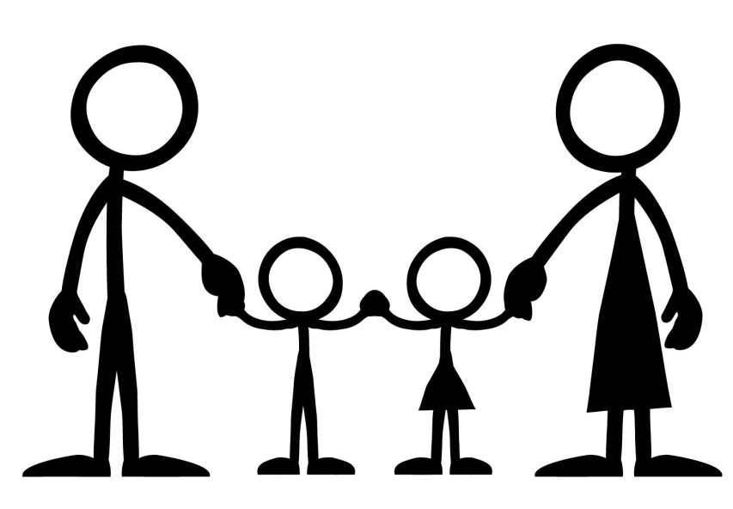
Svijet je postao ubrzan i zaluđen krivim stvarima i ljudima, prepun lažnih idola i iskrivljenih vrijednosti. U većini slučajeva sve se svodi na izgled i materijalno. Moralna vertikala je postala nešto što se traži povećalom, bilo da se radi o ljudima koji se bave politikom, poznatih iz svijeta umjetnosti ili čak religije. Smatram da je prije sve bilo drugačije te da su ispravne stvari i postupci, kao što je poštenje, poštovanje, pristojnost, imali svoju težinu. Moj uzor nije znanstvenik, nogometaš, pjevačica ili mislilac. Uzor mi je jednostavni nauk moje majke, savjet mojeg oca i unutarnji kompas kojim razlikujemo dobro od lošega. Sve ono što me i sam život nauči svakodnevno na lijep ili ružan način. Stanje mojeg duha i onog što mogu i želim postići u životu najviše ovisi o meni. Bitno uporište svakako je i moja obitelj bez koje mnoge stvari ne bi imale smisla.
U budućnosti tko zna, možda negdje „iskoči“ netko tko će zaplijeniti moju pažnju zbog onoga tko je i kakav je. Neki novi razlog, gesta ili djelo koje bi me natjeralo na razmišljanje pa možda i promjenu stavova prema životu.

Encouraged by the assignment to say who my role model is, I have found myself in the situation of not being able to pick somebody out of the many good and special people. My starting point was the fact that a role model should be somebody who has a good, quality life. However, I still haven’t found my role model.
The world has become speedy and crazed with the wrong things, the wrong people, full of false idols and twisted values. In most cases, everything boils down to appearance and material goods. It is difficult to find a moral person, be it a politician, an artist or a cleric. I think this was not the case in the past when honesty, respect and politeness were valued. My role model isn’t a scientist, a football player, a singer or a philosopher. My role model is simply my mother’s teaching, my father’s advice, the inner compass by which we differ the right from wrong and the good and the bad things life brings. The state of my spirit and what I want depends mostly on me. An important stronghold is surely my family, without which many things wouldn’t have sense.
Who knows, someday somebody may come up and draw my attention for the way they are, a new reason, gesture or deed that would make me think and change my attitude toward life.
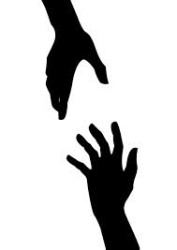
Potpuno je normalno da svi ljudi imaju svoj uzor na koje se možemo ugledati i koje cijenimo zbog onoga što rade ili načina na koji to rade. Pa tako i ja imam svoj uzor. Moj uzor je prijatelj iz Zagreba kojeg sam bolje upoznao prije par godina, a zove se Marko. Marko ima baku koja živi u mojem susjedstvu, pa smo se tako i bolje upoznali. On se inače bavi s više sportova, a najviše se bavi nogometom.
Mislim da svakome može biti uzor jer je on osoba koja svakog dana upoznaje nove ljude u svojoj okolini. Vrlo je komunikativan i vrlo odgovoran, kad nešto započne, to i dovrši, kad nešto želi, uvijek je uporan i na kraju to dobije. Marko je inače dosta živahan i tu se jako dobro slažemo. Kao što sam prije spomenuo, on trenira nogomet i to mu je posao, i jako ga poštuje i unapređuje. Divim mu se jer se zbog nogometa puno toga odrekao, a čega se ja nikad ne bih mogao.
Njegov me tjelesni izgled fascinira, ali naravno uz puno truda i ja bih imao dosta dobro razvijene mišiće kao što ima on. On je osoba koja živi zdrav život, a to mi se kod njega jako sviđa, te me potiče da i ja što više živim zdravo.
Uvijek me uči kako treba najbolje postupiti u nekim trenucima, ipak je stariji pa i iskusniji. Na primjer, kad se posvađam sa starcima, malo popričam s njim i on mi uvijek kaže najbolji savjet da to ispravim. Svaki čovjek treba imati svoj uzor, tako da ima poticaj za život.

It is completely normal to have a role model to follow and appreciate them for things they do or the way in which they do them. I, too, have a role model my role model is my friend from Zagreb whom I met a few years ago, and his name is Marko. Marko’s grandmother lives in my neighbourhood and that is why we became good friends. He does a few sports, mostly football. I think he can be anyone’s role model because he is a person who meets new people every day. He is communicative, responsible, always finishes things he started and persistent in getting what he wants. Actually, Marko is quite lively and we get along well in this field. As I mentioned earlier, he trains football and this is his job, he respects it a great deal. I admire him because he had to sacrifice many things for football, some things I definitely couldn’t. His physical appearance fascinates me, but, of course, I would have muscles he has, if I trained as much as he does. He is a person who lies healthily and this is what I like about him, and also encourages me to live healthier. He always teaches me how to act in certain situations, well, he is older and more experienced than me. For example, when I fight with my parents, I talk to him and he always gives me the best piece of advice how to make it right. Everybody should have their role model so that they could have an incentive in their life.

Kada bih morao birati svoj najbolji uzor, to bi zasigurno bio mamin stric iz Australije. Čovjek koji je doslovno golim rukama izgradio svoje malo carstvo.
Mamin stric, Steve Horvat, živio je u siromašnoj obitelji sa sedmero braće. Često su prolazili dani u kojima je dnevno pojeo samo komadić kruha i tanjur mlijeka. S 19 godina odlučio je prebjeći granicu jer više nije mogao podnijeti životni standard u kojem je živio. Kada je stigao u Australiju, bio je smješten u jedan kamp gdje je crkva smještala izbjeglice. Već nakon nekoliko tjedan zapazio ga je agent kako igra nogomet i odlučio ga pozvati u svoj tim. Tijekom godina, kako se penjao na ljestvici u nogometu i upoznavao sve više ljudi, upoznao je čovjeka koji mu je ponudio posao u svojoj firmi i da nauči zanat. Godinu dana kasnije upoznao je Traudu, zaljubili su se i vjenčali. Naravno, počeli su graditi prvu kuću i dobili dva sina. Kada je izučio zanat, odlučio je otvoriti svoj obrt. Nenadano je posao krenuo i počeo je stjecati puno novca, sve dok nije sklopio ugovor sa Shellom, taj posao bio je kao Big Bang. U Hrvatsku se vratio 20 godina kasnije i unatoč svom bogatstvu, u duši je ostao srdačan i pokoran kao da nikada nije ni napustio svoje selo. Već 40 godina pomaže cijeloj obitelji u Hrvatskoj i ne pita koliko treba.
Moj uzor je Steve Horvat, hrabar čovjek koji je trbuhom za kruhom krenuo u nepoznati svijet i ostvario sve što čovjek može poželjeti. Čovjek koji unatoč svom bogatstvu nije promijenio svoja načela i principe i nikada nije zaboravio ono najvrjednije a to je obitelj i dom.

If I were to choose my role model, it wold definitely be my mum’s uncle from Australia, a man who literally built his empire with his own hands. My mum’s uncle, Steve Horvat grew up in a poor family with seven siblings. There were many days when he ate only a small piece of bread and drank a cup of milk a day. At the age of 19, he decided to flee abroad because he just couldn’t live in such conditions anymore. When he got to Australia, he was placed into one the refugee camp, organized by a church. After a few weeks, an agent spotted him playing football and decided to invite him on his camp. Over the years, as he was climbing up the scale and meeting more people, he met a man who offered him a job in his firm to learn the trade. A year later he met Trauda, fell in love and got married. They started building their first house and got two sons. When he learned the trade, he opened his own business. The business was good and the money was even better, so he soon signed a contract with Shell, which was like a Big Bang for him. Twenty years later he returned to Croatia and, despite his wealth, remained a good-hearted, modest person, as though he had never left his village. He has been helping his family in Croatia for over 40 years.
My role model is Steve Horvat, a man who set off looking for a better living and made his dreams come true, a man who, despite his wealth, didn’t change his principles and didn’t forget the most valuable thing – his family and home.

Oscar Niemeyer je brazilski arhitekt i urbanist rođen 15. prosinca 1907. godine u Rio de Janeiru. Za njega sam saznao u školi i nakon što sam pročitao o njegovim projektima, shvatio sam da je jedan od najvećih arhitekata u posljednjih sto godina.
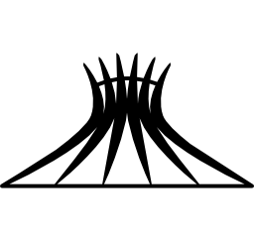
Niemeyer je jedan od najvažnijih predstavnika moderne arhitekture. Najpoznatiji je po upotrebi apstraktnih oblika i krivulja koje posebno obilježavaju svako njegovo djelo. Također je jedan od pionira što se tiče upotrebe armiranog betona u građevinama. Aktivan je više od sedamdeset godina te je u tom razdoblju doslovno preoblikovao Brazil. Jedan je od kreatora glavnog brazilskog grada Brazilije od koje je stvorio svjetski poznat, moderan i futuristički grad. Neka od njegovih najpoznatijih djela su katedrala u Braziliji, Nacionalni kongres Brazila i Muzej suvremene umjetnosti u Niteroi. On je također dizajnirao privatne kuće, zgrade, crkve, škole. Niti tu se nije zaustavio, također je izgradio razne spomenike i dizajnirao namještaj. Pomalo iznenađuje činjenica da je i u 105. godini još uvijek aktivan i posjećuje svoj radni atelje u kojem je izradio nacrte za neke od najvećih građevina moderne arhitekture.
Smatram da bi on sa svim svojim postignućima mogao biti savršen uzor nekim budućim arhitektima, pokazao je kako samo jedan čovjek može puno napraviti za svoj narod, a što je još važnije, kroz svojih 70 godina rada ostavio je veliko nasljeđe budućim naraštajima koji će moći uživati i diviti se genijalnosti ovog arhitekta. On je za mene velik uzor i smatram ga jednim od najvećih arhitekata u povijesti modernog doba.

Oscar Niemeyer is the Brazilian architect and urbanist born on December 15, 1907 in Rio de Janeiro. I found out about him at school and after having read about his project, realised he is one of the greatest architects in the last hundred years. Niemeyer is one of the most important representatives of modern architecture. He is best known for using abstract shapes and curves that mark his every work. He is also one of the pioneers in using reinforced concrete in his buildings. He’s been active for more than seventy years, and during this time, he literally reshaped Brazil. He is one of the creators of Brazil’s capital – the world-famous futuristic city. One of his most significant works are the cathedral in Brasilia, Brazil’s National Congress and the Museum of Modern Art in Niteroi. He also designed private houses, buildings, churches and schools. He didn’t stop there, he built monuments and designed furniture, as well. The fact that he is, at the age of 105, still active and visits his studio where he made some of his famous designs, is remarkable. I think that his accomplishments make him a perfect role model to future architects. He showed that one man can do a lot for his people, and most importantly, his 70-year work left a great legacy to future generations who will be able to enjoy and admire his genius. He is a great role model for me and I think he is one of the greatest architects in the history of modern time.

Od kad sam završio osnovnu školu, uzor mi je arhitekt Dinko Kovačić. Čovjek koji je od završetka studija radio kao odgovorni projektant u različitim projektnim biroima. Uz rad na projektiranju bio je i član Savjeta za urbanizam grada Splita. Danas radi kao profesor na Arhitektonskom fakultetu. Ja sam za njega saznao preko profesorice Sanje Markuš. Dojmio me se pa sam krenuo čitati o njemu i uz to čitanje poželio sam jednog dana biti kao on.
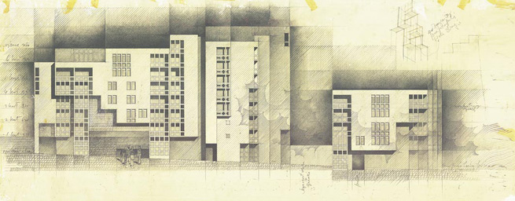
U životu uzor nam može biti bilo koja osoba koja svojim ponašanjem ili djelima potiče ljude na trud i uspjeh. Krenuvši u srednju školu, na prvom satu profesorica Markuš prikazivala nam je djela poznatih arhitekata. Tako smo došli i do vile Stupalo koju je projektirao Dinko Kovačić. Njegovo me se djelo dojmilo pa sam doma pročitao cijelu njegovu biografiju, projekte i uspjehe u životu. Što sam više čitao i divio mu se, sve sam više znao što želim od svog života. Glavni je razlog divljenju Kovačićeva predanost radu i stalne želje da se drugome čini radost, bez obzira radio on na skromnoj kući za odmor ili vili raskošne površine. Sva njegova djela vrhunac su dizajna, no ideje, tj. motive, uzima iz starijih povijesnih razdoblja poput moderne. Za svoj rad dobio je niz javnih priznanja i nagrada kao što je npr. Nagrada grada Splita za životno djelo.
Dinko Kovačić čovjek je koji je svojim trudom i predanošću u radu dospio daleko u životu i zbog toga mu se ja divim. Trudim se da postižem što bolje rezultate, pa ako Bog da i ako bude sreće i znanja, možda jednog dana budem poput njega.

Ever since I finished elementary school, my role model has been the architect Dinko Kovačić. After graduating from faculty he worked as an architect-in-charge in various studios. Besides planning, he was also a member of Split Urbanism Council. Currently, he teaches at the Faculty of Architecture. I learned about him from my teacher Sanja Markuš. I was impressed by him and started reading about his life which made me want to become a successful architect someday. A role model can be anyone who, with their personality or work, inspires people to do their best and succeed. I was in my first grade of secondary school when teacher Markuš showed the class some projects made by famous architects. She also showed us Villa Stupalo by the architect Dinko Kovačić. I as really astonished by his work and wanted to learn more about him. So I did. The more I read, the clearer it was to me what I wanted from my life. The main reason of my admiration was Kovačić’s commitment and making other people happy, no matter he worked on a humble weekend house, or a luxurious villa. All his works are state-of-the-art designs whose motives are taken from earlier historical periods.
He has won many awards, such as the award of the City of Split for Lifetime Achievement.
Dinko Kovačić is a man who has achieved great things by his hard work and commitment and this is why I admire him. I am trying to accomplish better results, and, god willing, someday I may become as successful as he is.

Moj uzor nije neka poznata ili slavna osoba, nego moj poznanik i prijatelj Tomislav. Upoznao sam ga na planinarenju na Sljemenu i od tada se stalno družimo i zabavljamo. On je inženjer elektronike i radi u jednoj većoj firmi u Zagrebu koja se bavi električnim uređajima. Jako je duhovit i zabavan, moglo bi se reći prijatelj kojeg svatko može poželjeti. Odabrao sam ga kao svoj uzor jer je uvijek spreman pomoći u nevolji, a i nekako je dosta sličan meni po svojim osobinama.
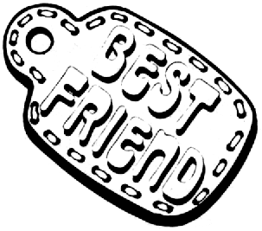
Tomislav je također član neprofitne organizacije Hrvatske gorske službe spašavanja u kojoj ustvari riskira svoj život da bi pomogao drugima te se samim time uvrštava među ljude koji su poželjni kao uzor. Uvijek se ponaša prijateljski i veseo je u društvu, te nije umišljen i ne misli da je centar svijeta kao neki ljudi, a to mene strašno smeta i ne volim takve ljude. Uvijek se oblači kao svi normalni ljudi i nema predrasuda. Naravno, krasi ga i mnogo drugih lijepih osobina, ali posjeduje jednu koja se meni najviše sviđa. Ljubitelj je ekstremnih sportova baš kao i ja te je po tome jako sličan meni. Moglo bi se reći i da je „pomalo lud“ što se toga tiče jer nema straha i uvijek sve pokuša, ma koliko to god bilo riskantno ili opasno, on ne posustaje i ide naprijed, a to je u stvari cilj našega života. Jednom mi je rekao kako je najbitnije da zapamtim tri riječi „vjeruj, pokušaj, ostvari“ koje su bitne u životu i ja se tih riječi pridržavam i zasada mi dobro ide.
Svatko u životu treba imati osobu koja mu je uzor i barem donekle se ugledati na tu osobu. Te osobe svojim ponašanjem i postupcima mogu pozitivno djelovati na nas i dati nam potporu baš kao što meni daje Tomislav u svakoj ideji koju osmislim i ostvarim i nadam se da ću još dugo imati tako dobrog prijatelja.

My role model isn't a famous person - my role model is my friend Tomislav. I met him on a hiking on Sljeme, and we have been having great fun ever since. He is an electrical engineer and forks for one of the biggest electronic companies in Zagreb. He is witty and really funny, you can say he is a friend to wish for. I chose him to be my role model because he is always ready to help and we are actually quite similar in character. Tomislav is also a member of The Croatian Mountain Rescue Service, a non-profit volunteer public organisation. He actually risks his life to help other people, and this makes him a true role model. He is always friendly and cheerful, he isn’t arrogant or self-centred (I dislike such people). He wears casual clothes and keeps an open mind to new ideas and people. He has many other traits I like, but my favourite one is that he likes extreme sports, just as I do. You could say he is a bit crazy because he is not afraid of trying out new, dangerous activities, no matter how risky they are and this is actually our lifetime goal. He told me one time the three most important words: ‘’believe, try, realize’’, and they have become my motto. Everybody should have a role model in their life and try to look up to it. Role models can make a positive influence on us and give us support, just as Tomislav supports me in my new ideas. I hope we will be friends for a long time.

Do prije četiri godine nisam imao uzora, bio sam potpuno bezbrižan i nisam razmišljao što mi život nosi. Dok sam bio u fazi ranog puberteta, počeo sam aktivnije slušat rock glazbu i proučavati je. Od svih bendova koje sam slušao najviše mi se dopao losanđeleski bend Red Hot Chili Peppers zbog svog „ludog i razigranog“ funk-rock stila glazbe. Peppersov gitarist John Frusciante je njihov najslavniji gitarist i jedan od najboljih gitarista svijeta.
Slušajući njih, počeo sam se amaterski baviti sviranjem gitare te mi je to kroz vrijeme prošlo u naviku i sada već dvije godine aktivno sviram. Johnov prepoznatljiv stil zvuka nadahnuo je mnoge mlade amaterske gitariste pa tako i mene. Uz to što je odličan gitarist on je i glazbeni producent i kantautor. Uz njegove pjesme zaboravim na stvarnost, jednostavno legnem na krevet, stavim slušalice i slušam. Ponekad uz njegove pjesme razmišljam o onome što me trenutno muči ili razveseljava. Mogao bih ga slušati satima i ne bi mi dosadilo.
Znam da nikad neću biti poput njega, a i ne razmišljam o tome, dovoljno mi je da uzmem gitaru, odsviram za svoju dušu neku njegovu stvar i nakon toga budem zadovoljan i lakše krenem u nove „školske pobjede“.
Nažalost, nikad ga nisam imao prilike vidjeti uživo, ali se nadam da će se jednog dana vratiti u svoj jedini bend RHCP s kojim će ponovo doći na neku buduću koncertnu europsku turneju. Ako se to dogodi, definitivno ću biti u prvim redovima.

Up until four years ago, I had no role models, I was carefree and didn't think much about life. At my early teens I started listening to rock music more actively and read about it. Of all the bands I listened to, I likes the L.A. band Red Hot Chili Peppers the most because of their crazy and playful funk-rock style. Their guitarist John Frusciante is one of the best and most famous guitarists in the world.
As I was listening to them, I started playing the guitar myself, and I’ve been playing it actively for two years now. John’s distinctive sound inspired many young amateur guitarists, and I am one of them. Besides being an amazing guitarist, he is also a music producer and song-writer.
His music makes me forget about the real world, I just lie on my bed, put my head phones in my ears and listen. While listening to his music, I sometimes think about the things that make me happy or sad. I could listen to him for hours. I know I will never be like him and I am not trying that, but I’m satisfied with taking my guitar and playing one of his songs for myself. After that, I feel relaxed and ready for new school victories.
Unfortunately, I haven’t had the chance of seeing him live, but I hope he’ll return to his one and the only band RHCP and do a European tour. If this comes true, I will definitely be in the first row.

U mojoj obitelji moja je baka uzor svima nama, a osobito meni. Ona je poput neke povijesne knjige pune zanimljivih, tužnih i sretnih priča.
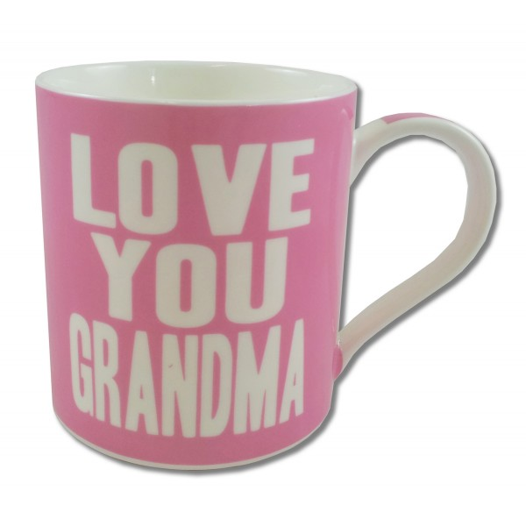
Imala je tužno djetinjstvo. Sa samo godinu dana izgubila je oca u ratu. Nikada ga nije uspjela zagrliti i reći mu da ga voli. Često mi o tome priča. Prisjećajući se trenutaka svog djetinjstva, često joj naviru suze na oči. Njezina obitelj je bila veoma siromašna. Hodali su goli i bosi. Zato mene stalno uči da moram biti zadovoljna onime što imam i cijeniti svaku sitnicu. Moja baka je borac. Uvijek daje sve od sebe. Ona je ta koja me je odmalena pazila, hranila i čuvala dok su roditelji radili. Svu ljubav je davala meni i mojoj sestri. Naučila me čitati i pisati. Uvijek me dočekala nasmijanog lica kada bih došla kući iz škole. Naravno, ponekad je pomalo dosadna, ali takve su sve bake. Brinu se za nas zato što nas vole. Moj djed, njezin suprug, umro je prije mog rođenja. Veoma mi je žao što ga nikada nisam upoznala. Baka mi priča priče i o njemu. Znam da je bio velik čovjek, kao što je i moja baka. Baka ima 73 godine i unatoč svim bolestima svaki mi dan skuha ručak i trudi se da mojim roditeljima pomogne koliko može. Uči me biti jakom osobom, strpljivom i hrabrom.
Želim biti poput nje, i jednog dana svojoj djeci i unučadi pričati kako je moja baka bila „prava žena, majka, baka!!!“

The role model to my whole family, and especially me, is my grandmother. She is like a history book full of happy and sad stories.
She had a sad childhood. One she was only one year old, she lost her father. She never got the chance to hug him and say she loved him. She often tells me stories of her childhood that make her cry. Her family was very poor – they didn’t even had enough shoes or clothes. This is why she always tells me to be satisfied with and appreciate everything I have. She is hard-working. She is the one who looked after me when I as little and taught me to read and write. She gave all her love to me and my sister. She would always welcome me with a smile when I came home from school. She can sometimes be a bit boring, but all grandmothers are sometimes like that. They take care of us and love us. My grandfather, her husband, had died before I was born. I am sorry I didn’t meet him but my grandma tells me stories about him. I know he was a great person, just like my grandma. She is 73 and despite her age and illness, she cooks for me every day helps my parents as much as she can. She is teaching me how to be a strong, patient and brave person. I would like to be like her someday and tell my grandchildren stories about my amazing grandma.

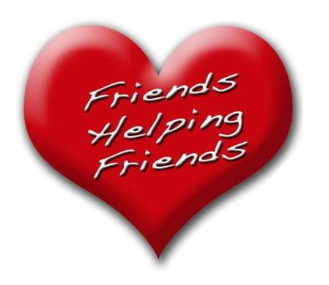
Moj uzor je Tena Cvek. Ona je moja sestrična, firmana kuma i najbolja prijateljica. Poznajemo se od malih nogu. Pohađa srednju školu u Zaboku. Tena se meni najviše sviđa zbog svog ponašanja. Uvijek je pristojna i pažljiva, nikada nije nekulturna ili bezobrazna. Potiče me da gledam svijet sa drugačije, ljepše strane. Volim kod nje to što je optimistična i ne želi biti kao drugi, već ono što ona zaista jest. Ona mene čuva kao kap vode na dlanu. Posebna je po svojoj dobroti i toplini, koju je uvijek spremna pružiti i najgorem neprijatelju. Željela bih biti poput nje, uvijek vedrog duha i nasmiješena. Cijenim je kao osobu zato što će mi uvijek dati dobar savjet ako dođem u nevolju. Kada god sam bila tužna ili ljuta zbog nečega, prvo sam nazvala nju, jer me je ona uvijek znala utješiti. Nikada nije bila dvolična, uvijek kada joj je nešto smetalo kod određene osobe, ona je to njoj rekla u lice, nikada nije pričala ljudima iza leđa. Također, Tena nikada nije izdala moju tajnu, tako da sam se uvjerila da se njoj uvijek mogu povjeriti. Kada bi svijet bio pun osoba kao što je ona, svijet bi bio pun dobrote i sreće.
Svojim ponašanjem Tena pozitivno utječe na mene. Nije mi važno imam li dvadeset ili sto prijatelja, znam da imam takvu prijateljicu kao što je Tena. Volim je!

My role model is Tena Cvek. She is my cousin, my confirmation sponsor and my best friend. We have known each other since we were little girls. Today, she is a student of a secondary school in Zabok.
I like Tena because of her behaviour. She is always polite and considerate and tells me to always look on the bright side of life. I like her optimism and originality. She takes good care of me. She is special for her kindness and warmth she gives to both her friends and enemies. I would like to be like her, high-spirited and smiled. I appreciate her as a person because she always gives me advice when I am in trouble. When I am sad or angry, I always call her first because I know she will comfort me.
She is never hypocritical, always speaks her mind and never talks behind people's back. She knows how to keep secrets, so my secrets are safe with her. The world would be a better, happier place if there were more people like her. Tena affects my life in a positive way. It doesn’t matter how many friends I have, as long as I have her as my friend. I love her!
Meni je uzor moj prijatelj Marko. Upoznali smo se prije pet godina u Zagrebu, kod tatinog prijatelja koji je tada slavio rođendan. U početku se nismo baš družili, ali kasnije smo sklopili pravo prijateljstvo. Marko je sada već odrastao i po zanimanju je liječnik.
Marko je zaslužio da bude uzor meni i svima koji ga poznaju jer on je poseban čovjek. Kod njega mi se najviše sviđa to što voli pomagati ljudima kojima je pomoć potrebna. On nikad neće odbiti osobe koje ga mole za pomoć i uvijek će to napraviti s voljom i bit će ponosan na to kasnije jer će znati da je učinio dobro djelo. Marko radi u bolnici i tamo se često nalazi u raznim situacijama, nekim opasnim i nekim manje opasnim. Marko se s pacijentima zabavlja, oni pričaj viceve, šale i slično kako bi se pacijenti što ugodnije osjećali i ne bi mislili na svoje probleme. On uvijek nađe neko rješenje protiv problema. U slobodne vrijeme organizira humanitarne koncerte, kako bi i na taj način pomagao bolesnim i nemoćnim osobama.
Jednog dana i ja bih htio biti poput Marka, pomagati ljudima baš kao i on. Kada bi barem svi ljudi bili kao on, svi si međusobno pomagali, ne bi bilo ratova i svađa, ljudi bi se jednostavno voljeli i život bi bio lijep.

My role model is my friend Marko. We met five years ago in Zagreb at his birthday party. At first, we didn't hang around much, but later we became best friends. Marko is an adult now and works as a doctor. Marko deserves to be a role model to me and everybody who knows him because he is a really special person. What I like about him best is that he is always willing to help people. He would never refuse to help somebody. He is proud of this because he knows it is the right thing to do. Marko works in a hospital and sees all kinds of, sometimes dangerous, situations every day. He tells jokes to his patients and makes them laugh so that they don’t think about their problems. He always finds the solution to any kind of problem. In his free time, he organizes concerts to help sick people. I would like to be like Marko someday and help people like he does. If only people were like him, everybody would help each other and there wouldn’t be wars or fights. Life would be nice!

Moj uzor je Antonio Glas. On je moj prijatelj iz razreda. Upoznali smo se prvog dana nastave. Veoma je tih i koliko-toliko mirna osoba. Sasvim je običan, dobar čovjek i dobar prijatelj. Prije bi priznao da je on kriv, makar nije, nego da izda prijatelja.
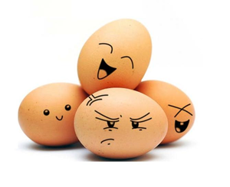
Prvog dana nastave ja njega uopće nisam primjećivao, bio je veoma tih i povučen, a kad smo se upoznali, sve je postalo drugačije. Ima veoma dobru osobnost. On je prijatelj kakvog si svatko može poželjeti. Uvijek će biti tu uz tebe, pomoći ti kad god ti zatreba pomoć. Nikad te neće ni za što okriviti, radije će šutjeti i dobiti jedan nego da kaže da je netko drugi kriv. Antonio posjeduje osobine pravog prijatelja: odan je, pun povjerenja uvijek će te saslušati. U pravom životu te osobine kod ljudi je teško naći jer svijet se mijenja, danas sutra te možda već najbolji prijatelj izda, ali on je baš ono suprotno - nikada, ali nikada ne bi izdao prijatelja. Jedanput u prvom razredu ja sam bio kriv za nemir na satu, a profesor je uporno okrivljavao njega, ali on je i dalje šutio i trpio i ni u kojem trenutku nije pomislio da bi rekao da sam ja kriv, jednostavno to rade pravi prijatelji.
On mene svakim danom sve više i više razveseljava. Uvijek je smiješan, uvijek govori neke viceve od kojih se cijeli razred smije, uvijek je poseban i nasmijan. Jednostavno to je on.

My role model is Antonio Glas. He is my classmate. We met on the first day of school. He is a very quiet and somewhat even-tempered person. He is an ordinary, good man and a good friend. He would rather take responsibility for something he didn't do, than betray a friend.
On the first day of school I didn’t even notice him, he was very quiet, and when we got to know each other better, everything changed. He has a great personality. He is a friend to wish for. He will always be there for you, help you whenever you need. He will never blame you for anything, he would rather be quiet and get a bad mark than tell on somebody. Antonio has the qualities of a true friend, he is loyal, trustworthy and he will always listen to what you have to say. It is difficult to find people with these qualities in real life because the world is changing fast and today’s friend can betray you tomorrow – this is something Antonio would never ever do. One time in the first grade, I was responsible for disturbing the class, and the teacher kept blaming Antonio, but he didn’t want to say that I was the one disturbing the class. This is something a true friend would do for you.
He makes me happier each day. He is always funny and tells jokes that make the whole class laugh. He is special – one and the only.

Moj uzor je Matija Steklar. On ide sa mnom u razred. Upoznali smo se na početku prvoga razreda. Matija dolazi iz Mača i tamo trenira nogomet. Jako voli ribolov. On bi trebao biti uzor drugima jer je uvijek spreman pomoći nekomu i uvijek je nasmijan i veseo.
Kod Matije mi se najviše sviđa njegov smisao za humor. Nekada kaže tako dobru foru i onda se njoj smijemo cijeli dan. Matija je stvarno pravi prijatelj. On jako voli pjevati. Svaki sat na tjelesnom je zabavan zbog njega. Prvo u svlačionici počne glasno pjevati pa ga čuje i profesorica i ostatak razreda u dvorani, a kada počnemo vježbati, on ili smisli neku smiješnu vježbu ili napravi nešto pa se cijeli razred smije. Matiju bih mogao prepoznati na kilometre. Visok je i ima specifičan osmijeh, od uha do uha. Njega rijetko kad vidim ozbiljnog. Često znamo imati „dubokoumne“ razgovore u kojima se samo smijemo.
Kad god vidim Matiju, uvijek se počnem smijati. On u razredu donosi veselje i smijeh. Da on ode u neki drugi razred, bilo bi mi jako žao jer ne bi bilo tako zabavno u razredu. Matija bi trebao biti svima uzor jer takvih ljudi, kao što je on, nema puno na svijetu!
My role model is Matija Steklar. We go to the same class. We met on the first day of school. Matija comes from Mače and trains football there. He likes fishing very much. He should be a role model to other people because he is always cheerful and willing to help.
What I like best about Matja is his sense of humour. Sometimes he tells me a really good joke and we laugh at it all day. Matija is a true friend. He likes singing very much. Each PE lesson is fun because of him. First, he starts singing loudly in the dressing room so that the teacher and other students hear him, and then, when we start exercising, he makes up something funny and the whole class laughs.
You can recognize him from a mile’s distance. He is tall and has a specific, wide smile. You can rarely see him being serious. We often have ‘’philosophical’’ conversations during which we only laugh. When I see Matija, I always start laughing. He brings joy and happiness to our class. If he changed classes, I would be very sorry because the class wouldn’t be the same without him. Matija should be a role mother to everybody because there are few people like him!

Uzor je vrlo teško odabrati. Teško je pronaći nekoga komu se divimo i koji nam svojim djelima i riječima pomaže u odlukama u životu, pogotovo kad smo u ovom teškom razdoblju - pubertetu.
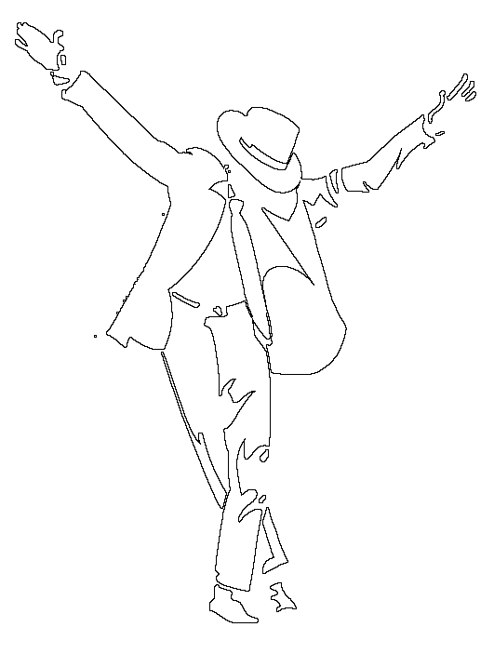
To su najčešće naši roditelji, a još više poznate osobe koje su ponekad krivi odabir za uzor. Moj osobni uzor je Michael Jackson. Ima mnogo razloga. Moji roditelji i mnogi prijatelji se ne slažu s tim, ali to je moj izbor. Michael je za mene jedna od najslavnijih osoba svjetske estrade. Možda svi njegovi postupci nisu bili ispravni, ali meni se sviđa njegov stav prema životu i uspjeh, unatoč svim lošim stvarima koje su mu se dogodile u životu. Od rane mladosti živio je kao „rob“. Njegov otac je od njega tražio nemoguće stvari i nije mu dozvoljavao da živi kao i sva ostala djeca. Kasnije su ga opsjedali novinari, a on je i dalje postizao sve veće uspjehe koji su poznati milijunima ljudi u svijetu. Razne optužbe i vrijeđanja nisu srušile njegovu popularnost. Nikad nije odustajao, baš nikad! Uvijek se borio za pravednost i pomagao gladnima i siromašnima. To je najvažniji razlog zbog čega je on moj uzor. Od djetinjstva živim slušajući njegovu glazbu i uvijek će tako ostati.
Ne mogu sa sigurnošću reći da je dobar primjer za uzor, ali meni je najbolji i uvijek će biti. Jednog dana željela bih kao on pomagati ljudima kojima je to najpotrebnije jer bih se tada osjećala ispunjeno i barem malo bila poput njega.

It is very difficult to choose a role model. It is hard to find somebody we admire and somebody who helps us with their own acts in making decisions during this difficult period called 'puberty'.
In most cases, role models are our parents, and more often celebrities, who are sometimes actually bad role models. My role model is Michael Jackson. There are many reasons for this. My parents and friends don’t agree with me, but this is my choice. For me, Michael Jackson is one of the most famous people in the world. Some of his actions may have not been right, but I like his attitude towards life and success despite all the bad things that happened to him. Ever since his childhood he lived as a ‘slave’. His father asked him to do impossible things and wouldn’t let him live like all other children. Later, paparazzi started haunting him, and he kept making successful records sold in millions of copies. All kinds of accusations and insults didn’t destroy his popularity. He never ever backed down. He always fought for justice and helped the poor and the hungry. And this is the most important reason why he is my role model. I’ve been listening to his music for years and I hope I always will. I am not 100% sure he is a good role model, but for me he is the best. Someday, I would like to help people because this would make me complete and a little bit closer to him.
Svi mi imamo svog uzora. Bio to neki glumac, pjevač, top model ili slično. Taj naš uzor je predmet našega savršenstva i cilj nam je postati poput njega, iako je to u većini slučajeva nemoguće. No, ne mora to uvijek biti tako. Nekome je uzor možda njegov roditelj, brat, sestra ili prijatelj.
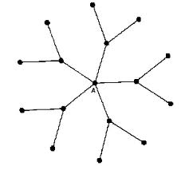
Moj uzor je moja prijateljica Mia. Iako je nekoliko godina starija, uvijek smo se dobro slagale. Naime, ona je pohađala gimnaziju i na početku nije bila baš neka učenica. Uvijek je radila probleme, upadala u loše društvo. Ali, kad joj je u glavu dospjelo da poslije srednje škole mora završiti i fakultet, počela je učiti. Upregnula je sve snage u učenje i dokazala svima da svatko tko želi može biti odličan učenik. Više se nije družila s lošim ljudima. Naučila im je reći NE. Upisala je farmaceutski fakultet i bila najbolja u svojoj generaciji. Sada je već pred završetkom faksa. Uskoro će se i udati i imati vrlo lijep život. Tko to ne bi htio!
Sada sam i ja shvatila da u životu nije važno biti slavan i bogat nego dobar i pošten. Dovoljno je zasnovati vlastitu obitelj i imati dobre prijatelje, tako će nam život biti neopisivo lijep. Jednog dana bih i ja željela nekome biti uzor. Lijepo je to kada netko želi biti poput tebe i imati život poput tvojeg!

We all have a role model, whether it is an actor, a singer or a top model. For us, our role model is a form of perfection and our goal is to become like it, although this is impossible in most cases. Well, in most, not all cases. A role model can be your parent, brother, sister or a friend.
My role model is my friend Mia. Although she is a couple of years older than me, we have always go along well. She enrolled at grammar school first but she was a bad student. She got into a bad company and did problems. But, when she realized that after high school she had to go to university, she started studying. She put all her energy into studying and proved anybody can be an excellent student.
She stopped hanging around bad people and learned to say 'NO'. She enrolled at the Faculty of Pharmacy and was top student in her generation. She is about to graduate. Soon, she will marry and have a wonderful life. Who wouldn't want a life like that!
Now I realized, too, that life isn’t about being rich and famous, but decent and fair. It is enough to have your own family and good friends – in this way, life is going to be amazing. Someday, I would like to be a role model, too. It is nice when somebody wants to be like you!

Osoba koja mi predstavlja uzor u životu definitivno je moja mama. Ona je bila sa mnom kroz cijeli moj život i pružala mi sve što mi je bilo potrebno.
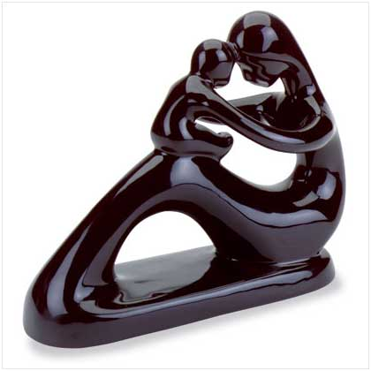
Kod moje mame mi se najviše sviđa to što je iskrena i čvrsta osoba. Kod nje nema pretvaranja, sve što kaže to i misli. Odlučno rješava sve teškoće koje ju zadese u životu. Nekad mi se čini da je dovoljno jaka da se suoči s cijelom vojskom. Marljiva je i vrijedna. Svaki zadatak koji dobije trudi se izvršiti najbolje što može. Kad se zna naljutiti na mene, ne reagira previše burno, nego smireno pokušava riješiti situaciju. Stroga je, ali pravedna. Njeni su dani vedri i puni veselja i optimizma. Uvijek je puna energije, ništa joj nije teško obaviti. Po prirodi ima snažan karakter. Ali kad je u nevolji i kad se emocionalno slomi, zna i zaplakati. Kao majka je vrlo strpljiva i puna razumijevanja. Odgaja svoju djecu najbolje što zna. Ponekad je svojeglava i tvrdoglava, ali nitko nije savršen pa tako ni ona. Iako je njezin posao skroman, ona ga voli raditi. Voli se družiti i zabavljati u svom radnom okruženju.
Moja majka je moj uzor jer je ona najbolja osoba koju poznajem. Ona meni nije samo majka, već i prijateljica kojoj se mogu povjeriti i reći sve što me muči. Znam da će mi ona pokušati pomoći na bilo koji način. Uvijek je uz mene i pruža mi potporu u svemu.

My role model is definitely my mother. He has been there for me my whole life and gave me everything I needed. I like her honesty and integrity best. She never pretends and always speaks her mind. She determinedly deals with any problem. Sometimes she seems so strong she could fight an entire army. She is hard-working. She tries to perform her duties the best she can. When she gets angry with me, she doesn’t overreact, but sorts things out in a calm way. She is strict but righteous. Her days are filled with joy, happiness and optimism. She is always full of energy and ready to do things. She has a strong personality, but when she is in trouble and breaks down emotionally, she sometimes even cries. As a mother, she is very patient and full of understanding. She raised her children the best she could. She is sometimes stubborn, but nobody’s perfect. Although her job is menial, she likes doing it. She likes her colleagues.
My mother is my role model because she is the best person I know. She is not only my mother, but she is also my friend who I can tell all my secrets and problems to. I know she will always try to help me no matter what. She is always there for me and supports me in everything.

