New Role Models
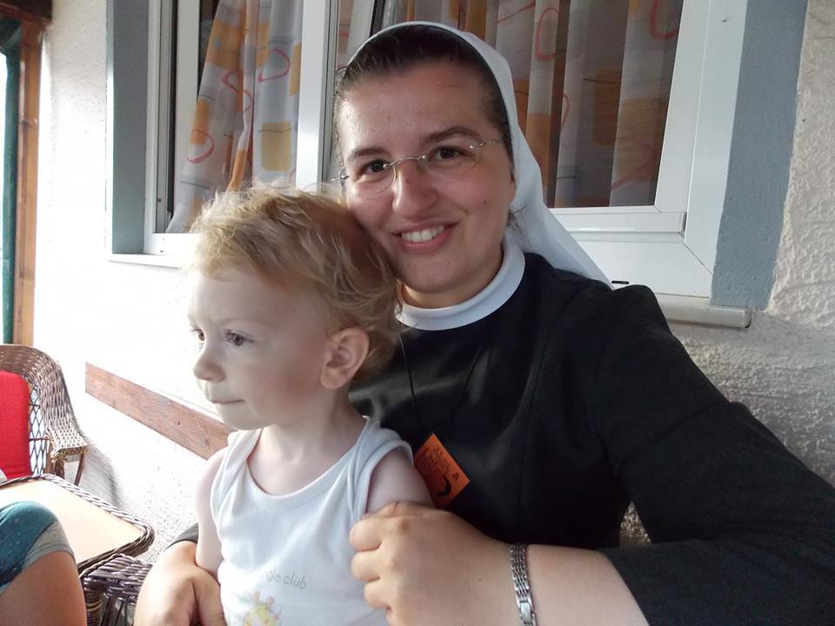
Dijana Lončarek
Domain: nun of the Holy Cross
Country of origin: Gornja Pačetina, Croatia
Date of birth: 1st June 1988

Significant facts about her life:
- dedicated to God since childhood
- after finishing physiotherapy at secondary VAT went to the monestry
- although her ​​life was difficult believes in God and joys life
- now studying at two faculties, physiotherapy and theology
- very talented and beautiful singer
- cheerful person full of optimism and hope

Achievements:
- role model for many young generations
- became popular because of her special attitude toward people and faith
- loved by colleagues, children and youth

Reason for making this choice:
- Dijana Lončarek was chosen for her humanity, good personality, commitment and she is very strong-willed. She is also very talented and has extraordinary social skills. Although her ​​life was difficult, she still believes in God and worshipes life. Very persevering in her studies and achiewing her objectives.

