New Role Models
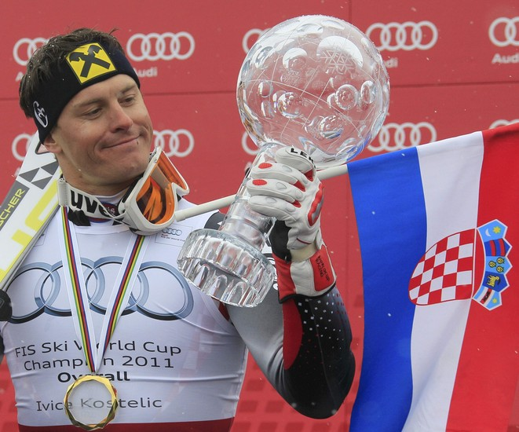
Ivica Kostelić
Domain: skiing
Country of origin: Croatia
Date of birth: 23rd November 1979
Significant facts about his life:
- Started his career in 1992
- had 13 operations on one knee
- one of the rare skiers who ski in all
disciplines
Achievements:
- three-time best athlete of Croatia
- won 4 Olympic medals
- won the Great Crystal Globe (2010-2011)
- seven-time best skier of the city of Zagreb

Reason for making this choice:
Ivica Kostelić is extremely talented and has a remarkable long career in skiing. Despite numerous injuries to his knee and back, he resumed his career and accomplished significant results. He has never had excesses in his private life. He has been motivating young people. Ivica is one of the most positive athletes in Croatia.

Ivona Fotivec I Stjepan Matekalo

