New Role Models
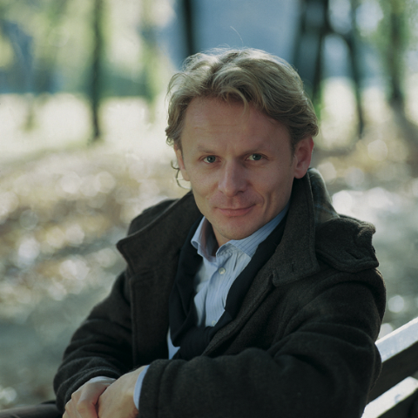

Ivan Đikić
Domain: medical doctor, scientist
Country of origin: Croatia
Year of birth: 1966
Important facts about his life:
- spent his cildhood in Hrvatsko zagorje, in a town called Marija Bistrica
- studied in Zagreb, was a straight-A student and graduated in only 4 and a half years
- finished scientific training at a university in New Yourk after which he moved to Frankfurt and worked as the youngest professor at a faculty of medicine
- got a job and became the manager of the laboratory for the molecular biology of tumors at Ludwig Institute for Cancer Research in Sweden
- gave away his awards to those in need and invested into new research
Accomplishments :
- discovered the mechanism by which human cells defend temselves from cancer development
- December 6, 2013 awarded with the most prestigious scientific award Gottfried Wilhelm Leibniz
- invented the protein which has an important role in tumor development and nervous system diseases
- April 4, Washington, received an Amercan Association for Cancer Research award
Reasons why he was chosen :
Ivan Đikić is talented, original and professional, completely dedicated to his work and the desire to help the whole mankind. He has been investing into the development of his knowledge wanting to perfect himself in his profession. He unselfishly invests his knowledge and money in order to help people.

